Project 4
I am an international student from Korea, and when I first came to Utah, I was very surprised by the climate. In Korea, we have a very humid summer in which I sweat all over my body once I go outside. However, in Utah, summer was so cool when I was in the shade, and the atmosphere was so dry, which made body lotion necessary. It was interesting to have this kind of hands-on experience, and this brought up a question for me, which is “How is the climate different around the United States?”
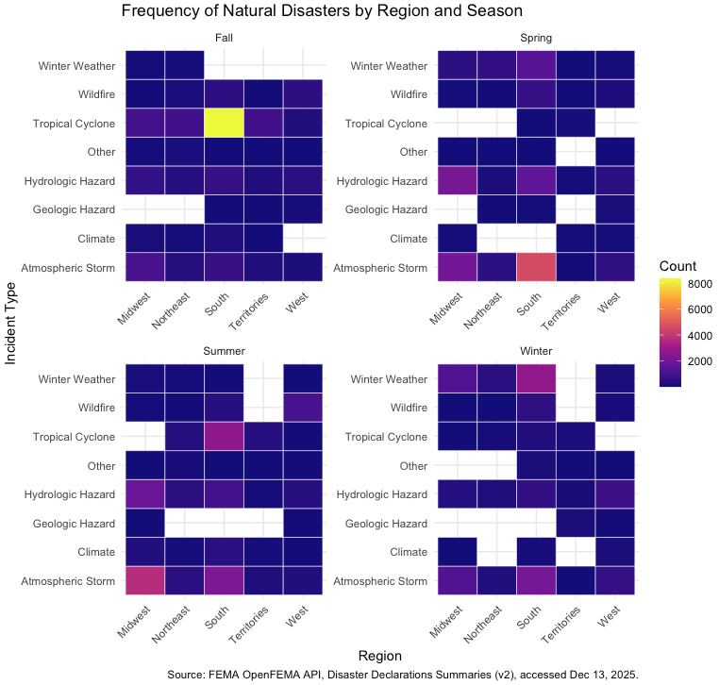
I decided to answer this question with Project 4, where I pulled FEMA Disaster Declarations Summaries. This API shows numerous natural disasters that occurred all around the United States. I sorted the natural disasters into similar types so that I can interpret the climate of the region.
I plotted a heatmap where I can see differences in all three parts, seasons, regions, and natural disasters. One of the most remarkable parts of the heatmap is the strong concentration of Tropical Cyclones( +8000 count) in the South regions during the Fall, which lines up with the peak of the hurricane season. Additionally, the Atmospheric Storms reach the climax in the South during Spring and in the Midwest during Summer, reflecting the annual shift in major thunderstorm and tornado activity across the central and southern U.S. The South regions tend to face the most diverse year-round natural disasters.
Beyond these outstanding events, the heatmap also shows moderate seasonal patterns. Winter Weather appears most often in the Midwest, Northeast, and South during the Winter, which matches the colder temperatures in these regions. Wildfires show a steady presence in the West throughout the year, chiefly during Summer and Fall, likely relating to the dry conditions.
Overall, the heatmap helps show how each region in the United States has its own dominant climate-related risks, making it easier to understand regional climate differences through the types of natural disasters that occur in different seasons.
In conclusion, it was a memorable experience to observe different climate change patterns in different regions of the United States. Seeing different climates in different regions while they are all in the same country was very interesting. I was able to deepen my understanding of the different climates and how they are concentrated in some regions. Next time, I would like to compare the climate pattern of the United States with that of Korea.

